Section 17
Video 93 – Bare Metal Embedded

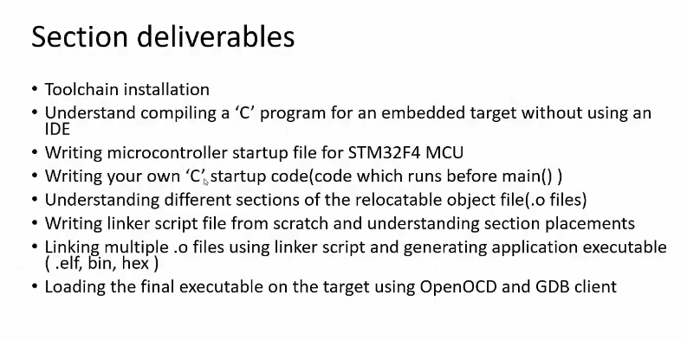
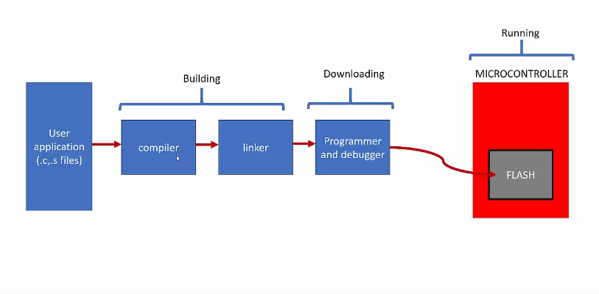

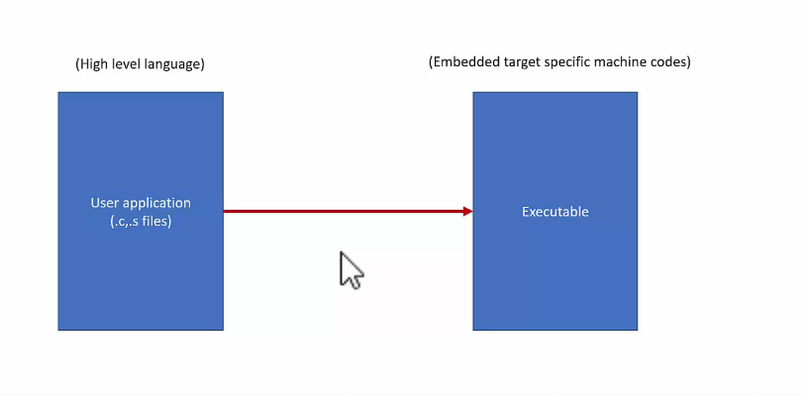
Video – Cross compilation and tool chains

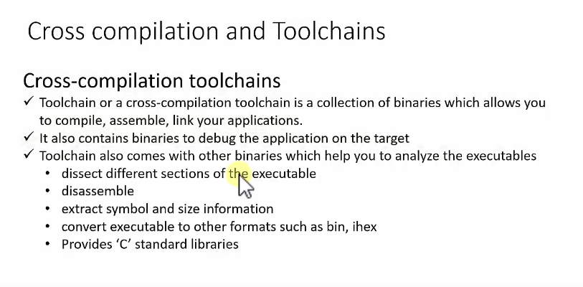

BUILD PROCESS

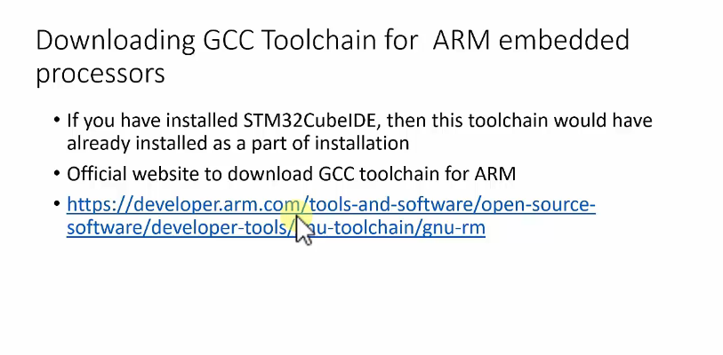
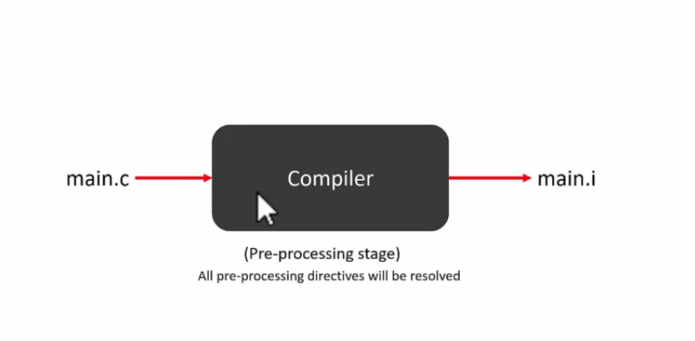
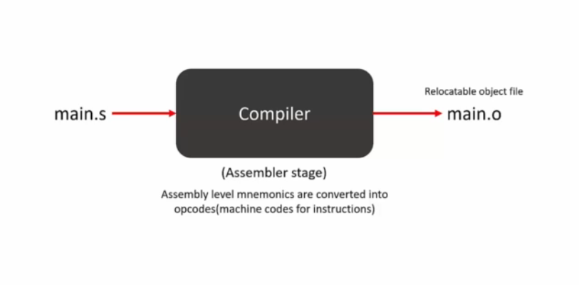

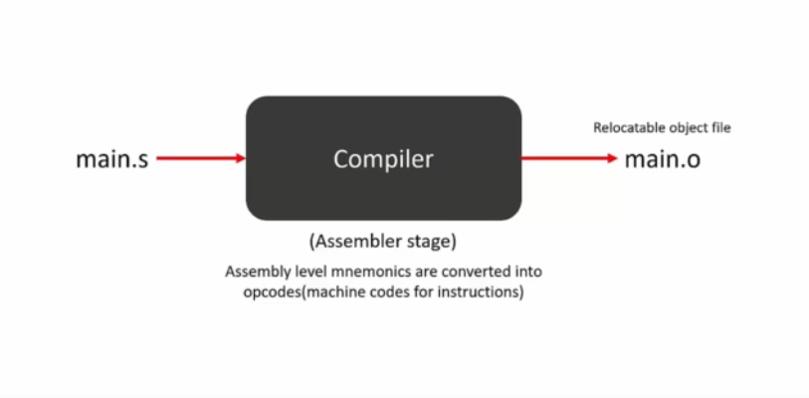
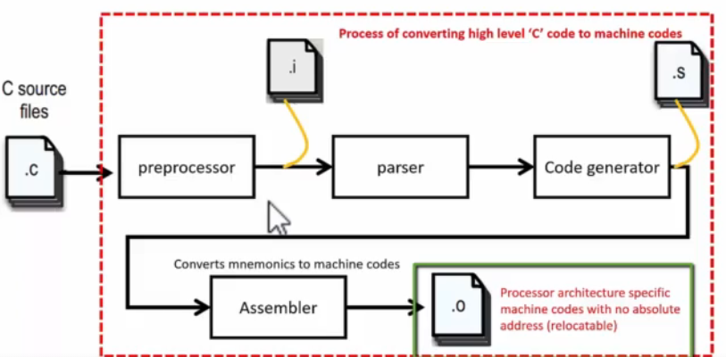

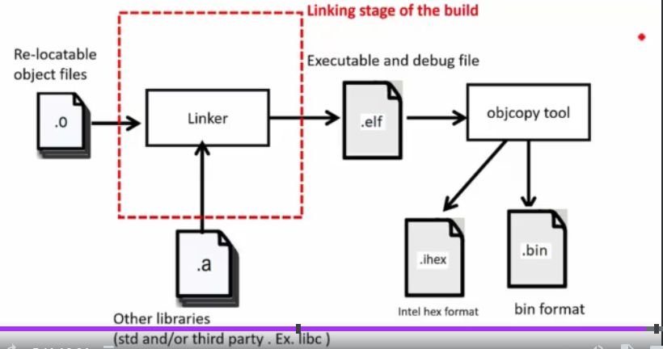
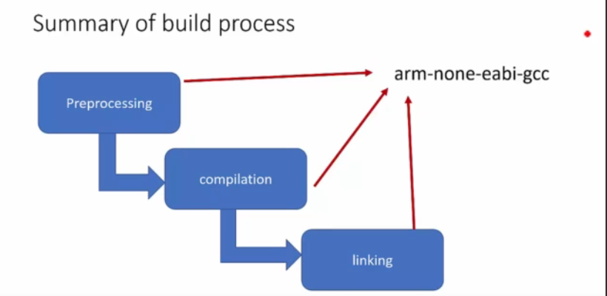

arm-none-eabi-gcc -c -mcpu=cortex-m4 -mthumb main.c -o main.o

arm-none-eabi-gcc: invoke compiler

-c: skip linking process, only compiles mcu

main.c: input file name

-o : output file

main.o: output file’s name

-mthumb: mthumb instructions state.

